SPT Electrical Connectors

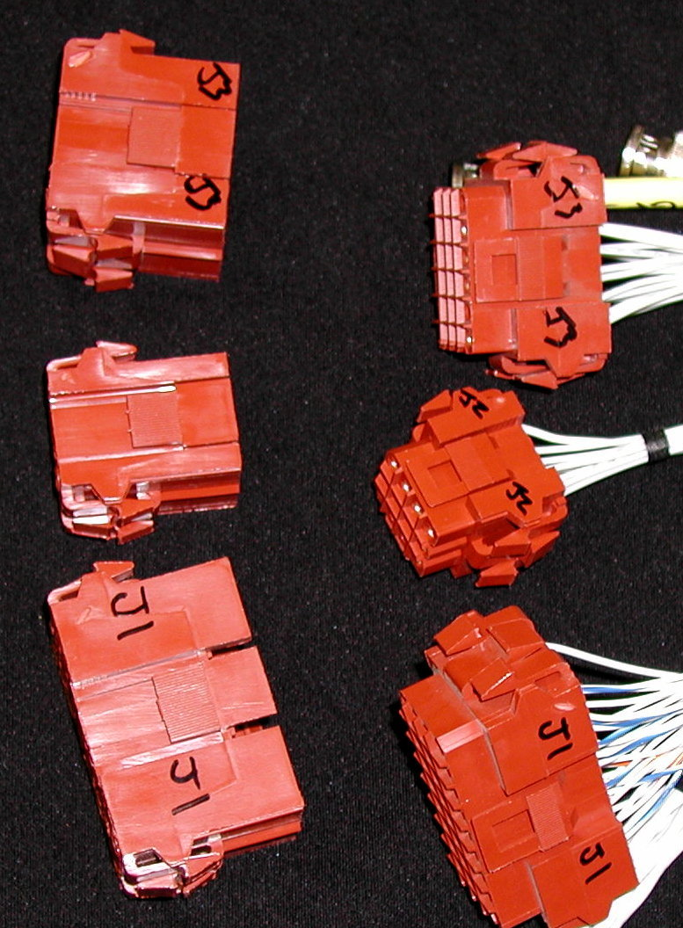
Panel cut-out dimensions

#Positions
width” height” (release tabs on this side)
4 .712 x .81
6 .712 x .998
9 .945 x .998
12 .945 x 1.19
18 .945 x 1.605
36 1.114 x 2.195

